**ANALYSING HOUSING PRICES OF METROPOLITAN AREAS IN INDIA**

**1.INDRODUCTION**

**The inception of the theory and idea of development, the common feature that**

**emerged in different point of time is the developmental gap that emerged in different**

**parts of the world and also among various parts of a country in a particular time period.**

**This disparity in development, like many other indicators, has also been reflected in**

**India. Traditional development theories believed that agriculture, industrialisation,**

**urbanisation, are significant ingredients of growth, and, ultimately important**

**prerequisites for achieving development. Within the economy itself, the status of**

**growth of a state can be judged through its performance in agricultural and industrial**

**production, performance of service sector and urbanisation, and their impact through**

**their contribution in income and employment generation at the national level. Thus,**

**house price behaviour may also reflect some short of developmental status of the**

**households of a country.**

**Keeping in view the above fact of rapid urbanisation and**

**regional disparities, it is not unexpected that it may lead to some sort of differences in**

**regional house prices, where housing and real estate are considered as major sources of**

**physical and financial asset. This also leads to the differences in the dynamics of house**

**price determination. It simply means that there might be shift of house prices in cities**

**from average, in the country, depending upon its economic status. For instance, average house**

**prices in the poorer provinces might be lower than the national average.**  **Similarly, for richer**

**states, the urban house prices, on average might be higher than the national average.**

**2. PROBLEM DEFINATION & DESIGN THINKING**

**2.1 Empathy Map**

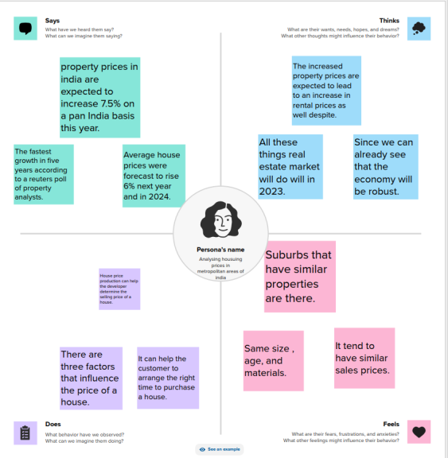

**2.2 Ideation & Brainstorming Map**

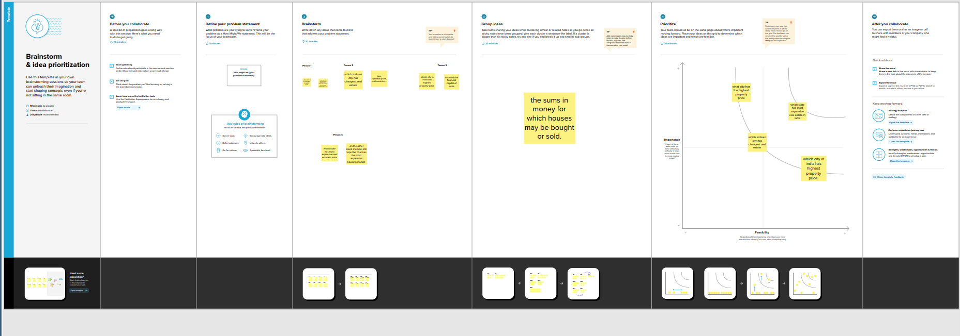

**3.RESULT**

**Dashboard 1**

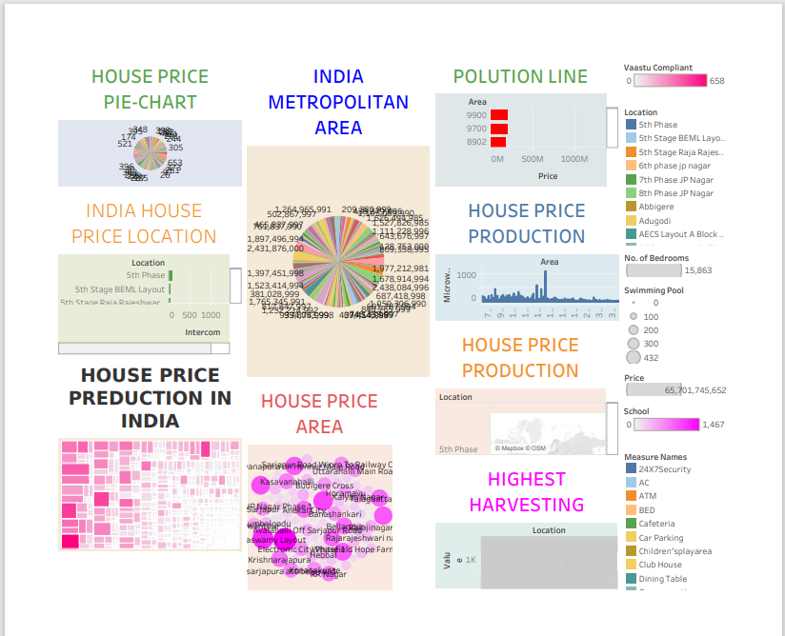

**4.STORY**



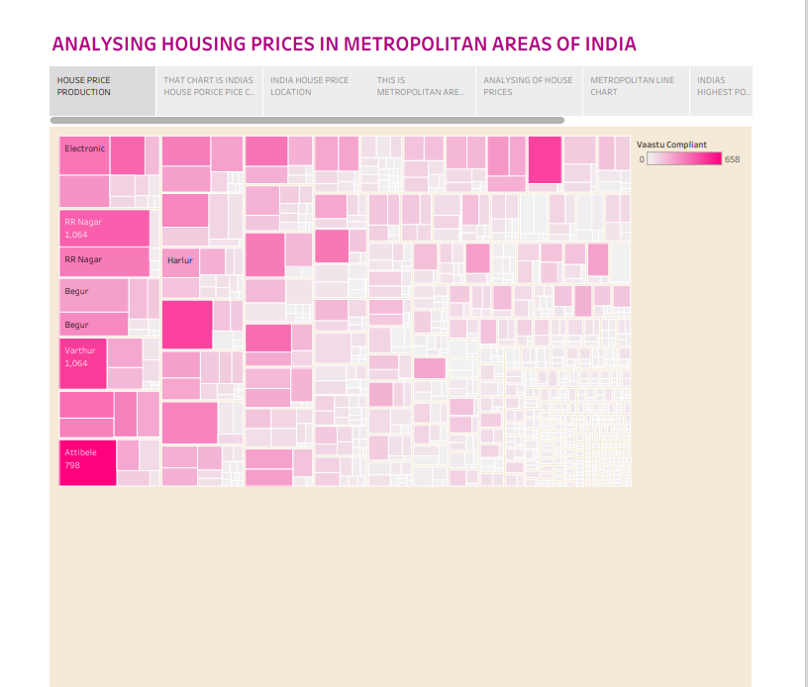

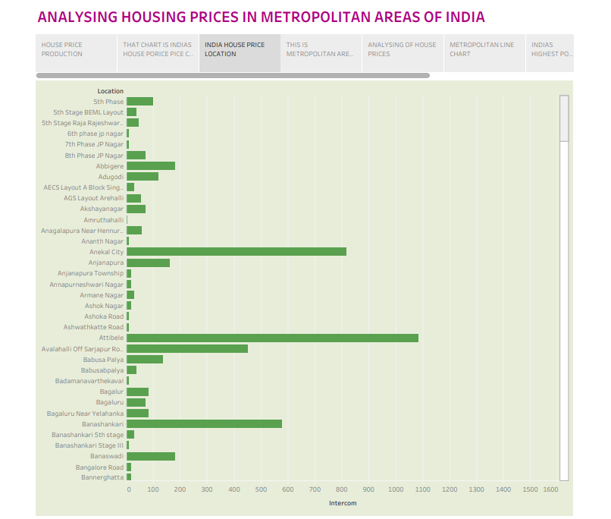

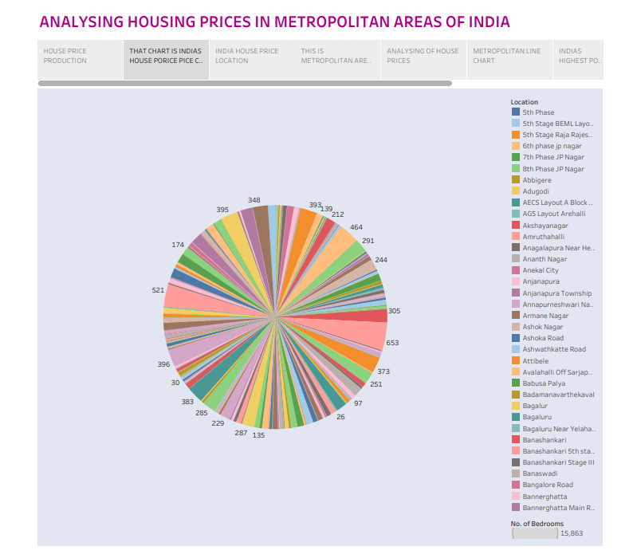

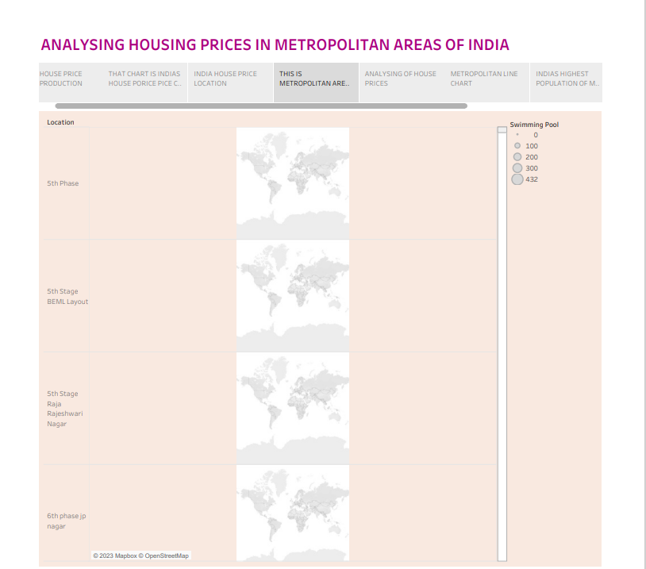

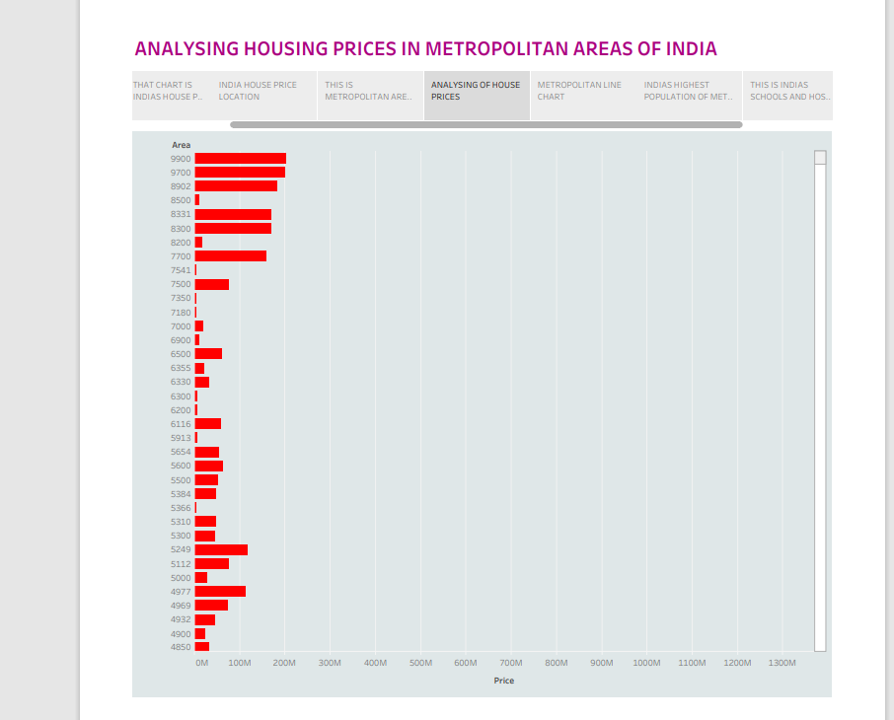

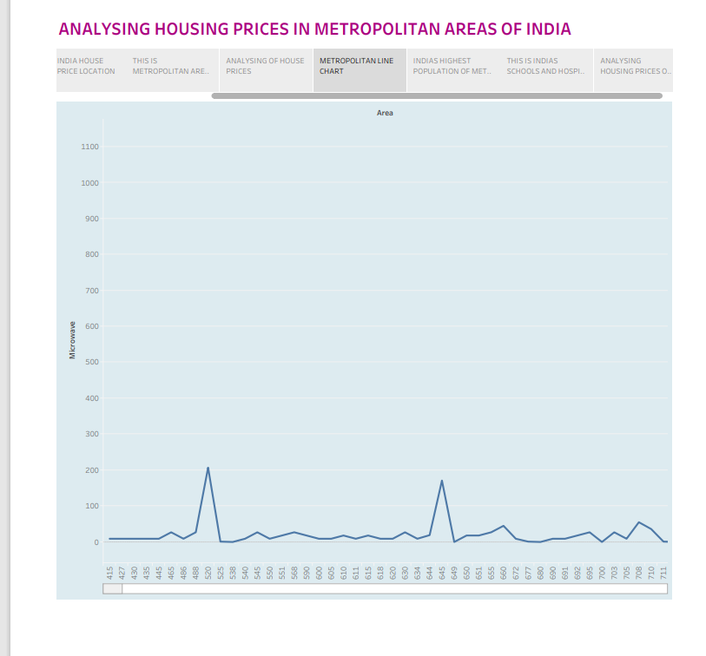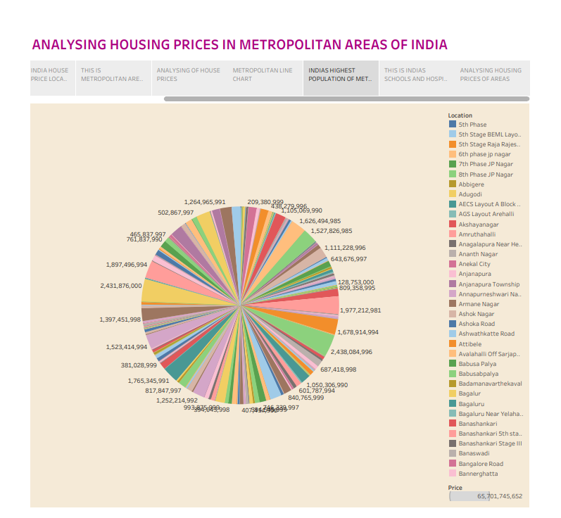

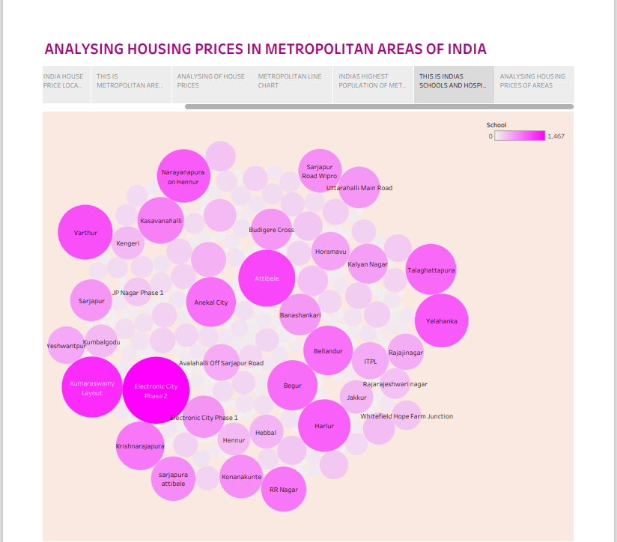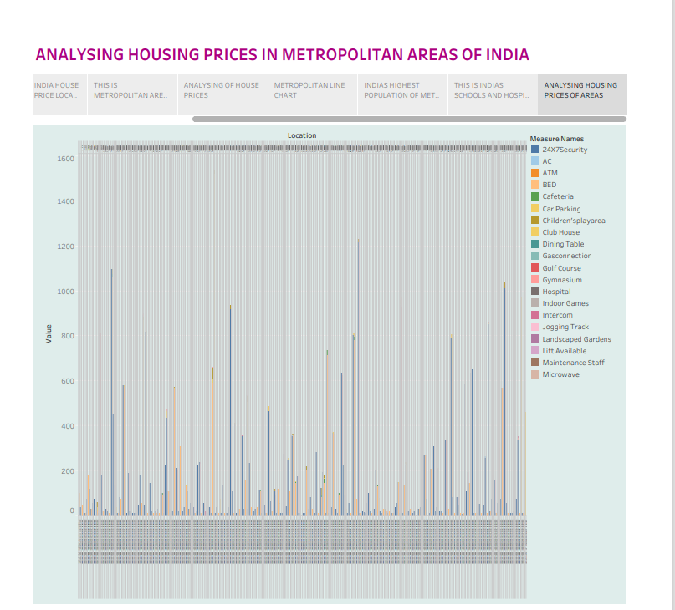

**House Price Determination: Theoretical Aspects**

The standard price behaviour of a good or its close substitute reveals the same price

movements and they generally vary within a price range, when they are sold at markets

located at different places (Shepherd, 1997; Lipczynski et al., 2005). Two houses in

two different locations are believed to be sold within the same market, if house prices

in one location impose a competitive constraint on house prices in the other location

(Motta, 2004; Carlton and Perloff, 2005). For example, whether a home owner is free

to set the price of his house in, say, Kolkata without any difficulty that may occur from

the house going to be sold in Delhi or in Mumbai or in any other city in the country.

Here, two …

The result of the Im, Pesaran and Shin panel unit root test is presented in Table 1. The

consistently high probabilities of the relative house prices indicate that the series is

consistently non-stationary and therefore diverges indefinitely in the long-run. The lack

of convergence of the relative house prices simply implies that separate metropolitan

cities in India function as separate housing markets in their respective localities. In

other words, the Law of One Price (LOOP) does not hold in Indian housing market

case.

**Table 1:**

Im, Pesaran and Shin (2003) Test Statistic and Probabilities of Relative

House Prices

MAIC MSIC

Statistic Prob. Statistic Prob.

Constant 0.22738 0.5899 0.33900 0.6327

Constant & Trend 1.61812 0.9472 1.61812 0.94, *, * indicates statistical significance at the 10%, 5% and 1% levels, respectively.

**Relative House Price Index**

Date

Hyder

abad

Farid

abad Patna

Ahmed

abad

Chen

nai Jaipur

Luck

now Pune Surat Kochi Bhopal

Kol

kata

Mum

bai

Benga

luru Delhi

2007:Q1 1,097 0,851 1,045 1,060 1,105 0,980 1,024 1,067 1,056 1,116 0,815 0,787 0,933 1,172 0,887

2007:Q2 1,050 0,832 1,037 1,067 1,102 1,042 1,017 1,048 1,037 1,123 0,927 0,820 0,964 0,967 0,960

2007:Q3 1,025 0,916 1,018 1,033 1,051 1,021 1,008 1,024 1,018 1,061 0,963 0,910 0,982 0,983 0,980

2007:Q4 1 1 1 1 1 1 1 1 1 1 1 1 1 1 1

2008:Q1 0,948 0,967 0,981 0,996 0,986 1,059 0,981 0,972 0,972 0,996 1,156 1,035 1,025 0,836 1,083

2008:Q2 0,899 0,936 0,965 0,993 0,974 1,114 0,965 0,946 0,946 0,993 1,302 1,068 1,049 0,683 1,161

2008:Q3 0,873 1,026 0,942 0,956 0,924 1,086 0,952 0,919 0,924 …

**5. Conclusions**

This paper analyzes whether the Law of One Price (LOOP) holds in the housing

market of fifteen metropolitan areas in India, namely Delhi, Mumbai, Bengaluru,

Kolkata, Chennai, Jaipur, Lucknow, Hyderabad, Pune, Surat, Ahmedabad, Patna, Faridabad, Kochi and Bhopal. We test the existence of LOOP using the Im, Pesaran and Shin (2003) panel unit root test based on quarterly data on residential property prices covering the period of 2007Q1 to2011Q4ofthe Indian housing market. Based on the criterion of price convergence, house prices in the 15 metropolitan cities do not

converge to the LOOP. This implies that the housing markets in the different areas

operate as segmented independent local markets. Therefore, house prices in one

…